C:\_tools\Python24\Lib\site.py

def setencoding():
#encoding = "ascii" # Default value set by _PyUnicode_Init()
encoding = "cp949" # Default value set by _PyUnicode_Init() #kusung 2006-06-04 10:26오전

"ascii" 를 "cp949" 로 변경

왜?

UnicodeEncodeError: 'ascii' codec can't encode characters in position 102-103: ordinal not in range(128)

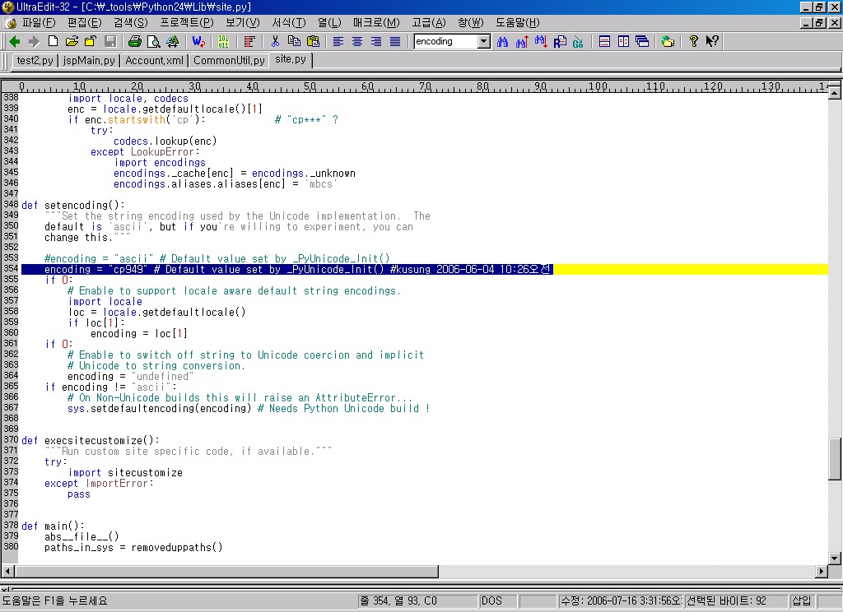

====
xml.parsers.expat.ExpatError
C:\_kldp\0716>jspMain.py Account.xml
Traceback (most recent call last):
File "C:\_kldp\0716\jspMain.py", line 131, in ?
Run()
File "C:\_kldp\0716\jspMain.py", line 111, in Run
aClassInfo = parseXml(aClassInfo, inXmlFile)
File "C:\_kldp\0716\jspMain.py", line 32, in parseXml
doc = xml.dom.minidom.parse(xmlFile)
File "C:\_tools\Python24\Lib\site-packages\_xmlplus\dom\minidom.py", line 1915, in parse
return expatbuilder.parse(file)
File "C:\_tools\Python24\Lib\site-packages\_xmlplus\dom\expatbuilder.py", line 926, in parse
result = builder.parseFile(fp)
File "C:\_tools\Python24\Lib\site-packages\_xmlplus\dom\expatbuilder.py", line 207, in parseFile
parser.Parse(buffer, 0)
xml.parsers.expat.ExpatError: not well-formed (invalid token): line 3, column 42

====
회사에서
Input xml 파일에 이상한 값이 들어 있으면 이런 에러가 난다.
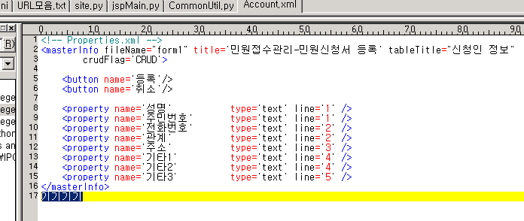
C:\_kldp\codegen\jspGen>jspMain.py Account.xml
Traceback (most recent call last):
File "C:\_kldp\codegen\jspGen\jspMain.py", line 49, in ?
Run()
File "C:\_kldp\codegen\jspGen\jspMain.py", line 30, in Run
aMasterInfo = parseXml(aMasterInfo, inXmlFile)
File "C:\_kldp\codegen\jspGen\jspMain.py", line 10, in parseXml
doc = getDomEncodeUtf8(xmlFile)
File "C:\_kldp\codegen\jspGen\CommonUtil.py", line 37, in getDomEncodeUtf8
doc = parseString(s) # 문자열을 이용한 파싱
File "C:\_tools\Python24\Lib\site-packages\_xmlplus\dom\minidom.py", line 1925, in parseString
return expatbuilder.parseString(string)
File "C:\_tools\Python24\Lib\site-packages\_xmlplus\dom\expatbuilder.py", line 942, in parseString

return builder.parseString(string)
File "C:\_tools\Python24\Lib\site-packages\_xmlplus\dom\expatbuilder.py", line 223, in parseString

parser.Parse(string, True)
xml.parsers.expat.ExpatError: junk after document element: line 19, column 0

